**פרויקט סוף - מחשוב ענן**

**שם המערכת:** Cloud Computing City

*הערה לשם המערכת: הרעיון שלנו בחשיבה העיצובית היה לעשות משחק בסגנון GTA, כמובן שלא יכלנו לממש את המשחק הזה, ורצינו לשמר את הסיפור רקע (במסך הwelcome מצוין גם סיפור רקע זה).

מטרת המערכת היא ללמד את המשתמש מחשוב ענן, הכולל נושאים כמו: סוגי עננים, מודל שירות, ארכיטקטורה של תשתית ענן וכו'. המערכת תלמד את המשתמש מחשוב ענן בדרך של משחק.

**דרישות פונקציולנליות –**

1. המערכת מאפשרת למשתמש לצפות בסרטוני הסברה
2. המערכת מאפשרת למשתמש לענות על שאלות מרובות ברירה
3. המערכת מאפשרת למשתמש לצפות בסיום התוצאות שלו לאחר כל סשן
4. המערכת מאפשרת למשתמש לצפות במיקום שלו בהשוואה לשאר השחקנים
5. המערכת מאפשרת למנהל מערכת להוסיף שאלות

**דרישות לא פונקציונליות –**

1. Performance: מימשנו את המערכת כך שתעבוד ביעילות מול ה-DB. בתחילת ריצת התוכנית שלפנו את כל הנתונים מה-DB, ובעת הצורך עידכנו את הנתונים הללו.  
   לדוגמא: בעת משחק, כל שאלה נלקחת ממערך שבו שמורות כל השאלות, כך שלא נצטרך כל פעם לגשת ל-DB ולשלוף משם שאלה. כך זמני התגובה של המערכת יותר מהירים.
2. Usability: המשחק הוא בעל ממשק משתמש ידידותי. הוספנו כפתורי Help שנותן הסבר למשתמש לגבי המערכת כגון: מה כל כפתור בדף הבית עושה, איך צוברים נקודות וכו'.
3. Extensibility: המשחק מעוצב בצורה שמאפשרת הרחבה קלה של הפונקציונליות שלו, בכך שכתבנו לכל פונקציונליות פונקציה מתאימה לה. כלומר נמנענו מלממש פונקציות ארוכות או מסובכות אלא מימשנו פונקציות כך שכל פונקציה מבצעת דבר ספציפי.
4. Interoperability: המערכת שלנו משלבת אינטראקציה עם מסד הנתונים firebase.
5. Readability: הקוד שבנינו קל להבנה, השתמשנו במשתנים משמעותיים ובתיעוד מתאים.

**תרשים use-case:**

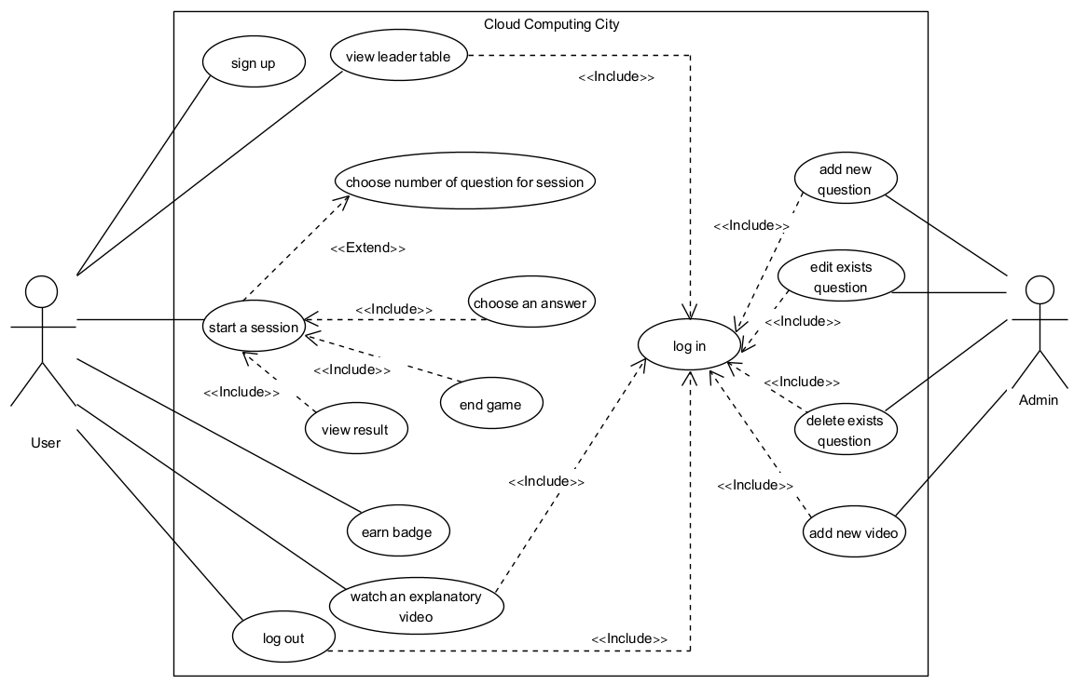

**איטרציות עבודה – SDP:**

|  |  |  |  |
| --- | --- | --- | --- |
| **Executor** | **Task** | **Requirement** | **Iteration** |
|  |  |  | Iteration 1 |
| Backend Developer - Suhel | Get user's data and question's data from the DB | Start the application |  |
| UI - Shiran | Create Welcome page |  |  |
| Frontend Developer - Qammar | Define functionality for buttons |  |  |
| QA - Raeed | Acceptance Test |  |  |
| Scrum Master - Emad | Prioritize tasks |  |  |
| Product Manager - Qammar | Feedback on design |  |  |
| Backend Developer - Raeed | Check user exists and user status (admin or not) | Connect to the application |  |
| UI - Shiran | Create Login page |  |  |
| QA - Amne | Acceptance Test |  |  |
| Product Manager - Qammar | Feedback on design |  |  |
| Backend Developer - Daniel | Enter new user data to the DB | Sign up |  |
| UI - Shiran | Create Signup page |  |  |
| Frontend Developer - Daniel | Checking user input |  |  |
| QA - Amne | Acceptance Test |  |  |
| Product Manager - Qammar | Feedback on design |  |  |
| Backend Developer - Shiran | Get question from DB | Start a game |  |
| UI - Shiran | Create game page |  |  |
| Frontend Developer - Raeed | Display the question and the answers |  |  |
| Frontend Developer - Shiran | Define functionality for buttons |  |  |
| QA - Qammar | Acceptance Test |  |  |
| Scrum Master - Emad | Promote agile practices |  |  |
| Product Manager - Qammar | Feedback on design |  |  |
| Backend Developer - Daniel | Update data user | End game |  |
| UI - Shiran | Create Result page |  |  |
| Frontend Developer - Daniel | Display result graph |  |  |
| QA - Amne | Acceptance Test |  |  |
| Scrum Master - Emad | Remove technical obstacles |  |  |
| Product Manager - Qammar | Feedback on design |  |  |
| Backend Developer - Suhel | Add question's data to DB | Add question |  |
| UI - Shiran | Create AddQuestion page |  |  |
| Frontend Developer - Suhel | Display input fields |  |  |
| QA - Amne | Acceptance Test |  |  |
| Product Manager - Qammar | Feedback on design |  |  |
| Backend Developer - Suhel | Edit/Delete question from database | Edit/Delete question |  |
| UI - Shiran | Create EditQuetion page |  |  |
| Frontend Developer - Suhel | Display question data |  |  |
| QA - Amne | Acceptance Test |  |  |
| Product Manager - Qammar | Feedback on design |  |  |
| Frontend Developer - Shiran | Change search input to dropdown for questions |  |  |
| UI - Shiran | Create Home page | User state |  |
| QA - Amne | Acceptance Test |  |  |
|  |  |  | Iteration 2 |
| UI - Amne | Create badge for top 3 users | Badge |  |
| Frontend Developer - Shiran | Display badge and score on user's home page |  |  |
| QA - Daniel | Acceptance Test |  |  |
| Backend Developer - Raeed | Display videos from the DB | Watch an explanatory video |  |
| UI - Amne | Create Cinema page |  |  |
| QA - Daniel | Acceptance Test |  |  |
| Frontend Developer - Shiran | Display user rank and top 5 users | Leader table |  |
| UI - Amne | Create Leader Table page |  |  |
| Frontend Developer - Daniel | Checking user input |  |  |
| QA - Daniel | Acceptance Test |  |  |
| Backend Developer - Raeed | Update user score after session on DB | User score |  |
| Backend Developer - Suhel | Update QuestionsThatBeenAnsweredCorrect field on DB |  |  |
| Frontend Developer - Suhel | Display user score on result page |  |  |
| Frontend Developer - Suhel | Display the amount of question that user answered correct in a row |  |  |
| QA - Shiran | Acceptance Test |  |  |
| Frontend Developer - Shiran | Display the number of questions according to user's choice | Start game |  |
| QA - Qammar | Acceptance Test |  |  |
| Backend Developer - Raeed | Update the DB as needed after admin successfully add/delete/edit a question | Admin pop-up |  |
| Frontend Developer - Raeed | Display a pop-up after admin successfully add/delete/edit a question |  |  |
| Frontend Developer - Suhel | In add question page change the level and correct fields to dropdown |  |  |
| QA - Amne | Acceptance Test |  |  |
| Frontend Developer - Shiran | Create and display a bar chart graph | Bar-Chart graph |  |
| QA - Amne | Acceptance Test |  |  |
| Backend Developer - Qammar | Add questions to db | DB updates |  |
| Backend Developer - Raeed | Add sessions games for users |  |  |
| UI - Amne | Create Add Video page | Add video page |  |
| Frontend Developer - Shiran | Display input fields |  |  |
| Backend Developer - Shiran | Add video's data to the DB |  |  |
| QA - Daniel | Acceptance Test |  |  |
| Scrum Master -  Shiran | Create maintenance guide | Maintenance guide |  |
| Product Manager- Amne | Calculate SUS grade | SUS |  |
| Scrum Master -  Shiran | Create user documentation | User documentation |  |
| Scrum Master -  Suhel | Create a short video describing the game | Video about the game |  |

**הפרויקט הסופי –**

**חישוב SUS –**

|  |  |
| --- | --- |
| **SUS Raw Score** | **SUS Final Score** |
| 61 | 152.5 |
| 63 | 157.5 |
| 59 | 147.5 |
| 67 | 167.5 |
| 72 | 180 |
| 81 | 202.5 |
| 66 | 165 |
| 66 | 165 |
| 72 | 180 |
| 68 | 170 |
| 71 | 177.5 |
| 68 | 170 |
| 76 | 190 |
| 80 | 200 |
| 71 | 177.5 |
| 74 | 185 |
| 69 | 172.5 |
| 77 | 192.5 |
| 71 | 177.5 |
| 81 | 202.5 |
| 67 | 167.5 |
| 76 | 190 |
| 77 | 192.5 |
| 80 | 200 |
| 54 | 135 |
| 71 | 177.5 |
| 62 | 155 |
| 75 | 187.5 |
| 75 | 187.5 |
| 83 | 207.5 |
| 80 | 200 |
| 65 | 162.5 |
| 74 | 185 |
|  |  |
|  |  |
|  |  |
|  |  |
| **71.27272727** | **178.1818182** |

**Average:**

**תיק מתכנת –**

*נציין שפירטנו את כל הפונקציות, מכיוון שמימשנו את הקוד כך שהפונקציות יהיו קצרות שמממשות דבר ספציפי, ולכן כולן חשובות ומרכזיות.

**Maintenance Guide -** Cloud Computing City

**File name:**

hw03.ipynb

**DB structure:**

**questions:**  
Id – contain the question's id  
question – contain the question contact.  
Option1, Option2, Option3, Option4 – contain the four answers.  
Correct – contain the correct option.  
Level – contains the difficulty level of the question.

**users:**  
Admin – contain 'yes' or 'no'. 'yes' for user with admin permission.  
Username – contain the user's username.  
Password – contain the user's password.  
CurrentQuestionsInARow – contain the maximum question that player answered correctly in a row.  
**Games**: save data on the sessions.  
(Note: for every user there is one game that contain session: -1 and sessionScore: -1 as default)  
 session – contain the session number.  
 sessionScore – contain the score that player got in the session.  
Score – contain the user's score.  
QuestionsThatBeenAnsweredCorrect – contain all the questions id that the user answered correct.  
userPlace – contain the user place compere the other users. (Note: this field added to the user data when he clicks on the Leader Table button)

**videos:**  
imgVideo – contain the image that will be display for that video in the Cinema page.  
title – contain the title that will be display for that video in the Cinema page.  
urlVideo – contain the URL video.

**DB variables:**

**res** - contain all user data from the db.  
**resQuestion** - contain all questions data from the db.  
**resVideo** - contain all videos data from the db.  
**easyQuestion** - contain all questions data with level easy from the db.  
**easyAndMediumQuestion** - contain all questions data with level easy and medium from the db.

**Global variables:**

**userDetails** – save the details on the user that current logged in  
**countCorrectAnswer** – count the number of correct answer in session  
**countWorngAnswer** – count the number of worng answer in session  
**questionNumberForGame** – the number of questions that user choose to play in session  
**countQuestionThatUserAnswerInGame** – count the number of questions that user answered in session  
**firstVideoOnPage** – save the index of the first video in the Cinema page  
**questionId** – contain the current id question that is displayed  
**qestionLevel** – contain the current level question that is displayed  
**additionalScore** – save the score that user earn in session  
**CurrentQuestionsInARow** – count the current number of questions that user answered correct in a row  
**maxQuestionsInARow** – contain the maximum questions that user answered correct in a seesion  
**start_time** – contain the time that user start play the session

**Score variables:**

scoreForEasyQuestion = 50  
scoreForMediumQuestion = 100  
scoreForHardQuestion = 150  
scoreFor3CorrectAnswerInARow = 30

**Functions:**

**def signUp():**  
input - none  
output - none  
do - display the Signup page.

**def addQuestionBtnAdminPage():**  
input - none  
output - none  
do - display the Add Question page for admin.

**def editQuestionBtnAdminPage():**  
input - none  
output - none  
do - display the Add/Delete Question page for admin.

**def addVideoBtnAdminPage ():**  
input - none  
output - none  
do - display the Add Video page for admin.

**def adminPage():**  
input - none  
output - none  
do - display the Admin home page.

**def logout():**  
input - none  
output - none  
do - display the Login page.

**def homePage():**  
input - none  
output - none  
do - display the Home page and call loadUserScoreAndBadge function.

**def walcomePage():**  
input - none  
output - none  
do - display the Welcome page.

**def loadUserScoreAndBadge():**  
input - none   
output - none  
do - load the user information and badge (if has).

**def cinemaPage():**  
input - none  
output - none  
do - display the Cinema page and call loadVideoForPage function.

**def updateUserDataAfterPlaying():**  
input - none  
output - none  
do - update user data after playing (update res array, userDetails and db).

**def resultPage():**  
input - none  
output - none  
do - calculate the time that user played and display it, call loadChartPie and loadBarChart function and display the result game.

**def loadChartPie():**  
input - none  
output - none  
do - create the chart pie that contain the number of questions that user answered correct and wrong.

**def loadBarChart():**  
input - none  
output - none  
do - create the bar chart that contain the user scores in the last previous sessions (up to 3).

**def register(userName, password, kwarg1=None):**input - userName: the username that user enter on the login page, password: the password that user enter on the login page  
output - none  
do - check the input, if some fields are empty or if username already in use, display a matched error message. If all inputs are filled correct it's entered the new user to the db, show a pop up and display the Login page.

**def clearMsgInPage():**  
input - none  
output - none  
do - clear an error message.

**def newUserExist(res, userName, kwarg1=None):**  
input - res: array that contain all users' details, username: the value that user enters in the username input in the Login page.  
output - True or False  
do - return true if the username already exists in the db.

**def connectCheck(userName, password, kwarg1=None):**  
input - userName: the value that user enters in the username input in the Login page, password: the value that user enters in the password input in the Login page.  
output - none  
do - if the user exists it's checked the user permission (admin/player) and display the page accordingly. In case the user enters invalid details, it's displayed an error message.

**def startGame():**  
input - none  
output - none  
do - call setQuestionNumberForGame function.

**def setQuestionNumberForGame(startGame, questionNumber, kwarg1=None):**  
input - questionNumber: the number of question that user choose to play in that session, startGame: equal to '1' if user press on the Start button, otherwise equal to '0'.  
output - none  
do - set the number of questions that user gone play in that session. Call load_question function.

**def user_exist_check(userName, password):**  
input - userName: the user's username value, password: the user's password value.  
output - True or False  
do - return true if the username and the password are correct and initializes userDetails accordingly, otherwise return False.

**def admin_check(userName):**input - userName: the user's username value,  
output - True or False  
do - return true if the user has admin permission, otherwise return False.

**def edit_question(question_id, level, question_text, option1, option2, option3, option4, correct):**  
input - question_id, level, question_text, option1, option2, option3, option4, correct: the value that admin enters in the fields input in the AddQuestion page accordingly.  
output - none  
do - update the question value according to the input fields in the db and initializes resQuestion. Display a pop-up with success message.

**def remove_question(question_id):**  
input - question_id: the question's id.  
output - none  
do - remove the question with the id provide in the input, initializes resQuestion and display a pop-up with success message.

**def addQuestion(question, correct, option1, option2, option3, option4, level, kwarg1=None):**  
input - question, correct, option1, option2, option3, option4, level: the value that admin enters in the fields input in the EditQuestion page accordingly.  
output - none  
do - check if there are no empty fields, if there is, display an error message. Otherwise, upload the new question to the db and add that data to resQuestion as well. Clear all input fields and display a pop-up with success message.

**def addVideoBtn(imgVideo, titleVideo, urlVideo, kwarg1=None):**  
input - imgVideo, titleVideo, urlVideo: the value that admin enters in the fields input in the AddVideo page accordingly.  
output - none  
do - check if there are no empty fields, if there is, display an error message. Otherwise, upload the new video to the db and add that data to resVideo as well. Clear all input fields and display a pop-up with success message.

**def display_popup_for_user(msg):**input - msg: the message to display to the user.  
output - none   
do - display a pop-up with a message.

**def initSearchDropdownQuestions():**  
input - none  
output - none  
do - get the questions from the db initializes the dropdown.

**def searchQuestion(id, kwarg1=None):**  
input - id: the question's id that as been choose in the dropdown.  
output - none.  
do - for the given id it's display the question data.

**def getQuestionsFromDB():**input - none  
output - question data  
do - get a random question according to user score (score < 700 - easy question, score < 1500 - easy/medium question, above 1500 - easy/medium/hard)

**def load_question():**  
input - none  
output - none  
do - display the Game page, call checkEndGame function, call getQuestionsFromDB and display the question and four answer.

**def checkEndGame():**  
input - none  
output - none  
do - check if this is the last question for the session if it is than display the next question button in the pop-up. Also update the countQuestionThatUserAnswerInGame and display it.

**def updataCountQuestionThatUserAnswerInGame():**  
input - none  
output - none  
do - raise the value by one in countQuestionThatUserAnswerInGame after user move to the next question.

**def updateCountAnswer(flag, kwarg1=None):**  
input - flag: contain '1' – if user answered correct or '0' – if user answered wrong.  
output - none  
do - if flag equal to '1' it raises the value countCorrectAnswer by one, otherwise it raises the value countWorngAnswer by one. Also, it counts the maximum questions that user answered in a row and update the additionalScore if needed.

**def updateBounsScore():**  
input - none  
output - none  
do - if user answered correct and press the end game it is update the bonus score, if needed.

**def updateCorrectAnswerAndScore():**  
input - none  
output - none  
do - enter the id question to the QuestionsThatBeenAnsweredCorrect array (contain all the id question that user answered correctly) and update the user score according to the question's level.

**def initFirstVideoOnPage(btnId, kwarg1=None):**  
input - btnId: contain 'nextPageVideo' or 'previousPageVideo'.  
output - none  
do - raise/decrease the valuein firstVideoOnPage by 6. Call loadVideoForPage function.

**def loadVideoForPage(startVideoOnPage):**input - startVideoOnPage: contain the video index that should be first in the page.  
output - none  
do - display 6 video on the Cinema page.

**def loadLeaderTable(leaderTableHTML = leaderTableHTML):**  
input - leaderTableHTML: Leader Table page.  
output - none  
do - call createRankUsers and display to the table the user rank and the top 5 users.

**def createRankUsers():**input - none  
output - sorted list by score with all users (not included admins)  
do - sorted all user according to their score, add 'userPlace' field to the user to indicate his rank.

**תיק משתמש –**

**User Documentation -** Cloud Computing City

Player:  
In this game you can learn cloud computing from the basic level to the advanced level. You will manage a cloud company; your goal is to be the biggest business in the city. To achieve that you will have to see videos, answer multi choice questions, and get score to increase your company rank and became the best CEO in the city.

Admin:  
You will be able to add new questions, to edit/delete questions and to add new videos.

**Welcome screen:**

* Press on Log In button to move to Log In page.
* Press on Sign Up button to move to Sign Up page.



**Log In screen:**

* Enter username and password.
* Click on Connect to log in to the game.
* Click on Sign Up button if you don't have an account.
* Click on Back button to go back to Welcome screen.
* Note: by not entering all the fields or entering wrong username/password and click on Connect, the user gets an error message.



**Sign Up screen:**

* Enter username and password.
* Click on Create Account button.
* If you don't want to sign up, click on Back button to go back to Welcome screen.
* Note: by not entering all the fields or entering a username that already in use, the user gets an error message.



**Home screen:**

* You can see your name, your total score and your record of questions that answered correctly in a row.
* You can see you badge (if you are one of the top 3 users)
* Click on Leader Table button to see you rank and top 5 users.
* Click on Cinema button to watch and lean new fields related to cloud computing.
* Click on Help button to get more information about the game.
* Click on the dropdown to select the number of questions you want to play in current session.
* Click on Start button to start a game.
* Click on Logout button logout from the game.



**The badges a user can get:**

|  |  |  |
| --- | --- | --- |
| **First Place** | **Second Place** | **Third Place** |
|  |  |  |

**Leader Table screen:**

* User can see his rank and the top 5 users.
* The user row in the table is marked.
* Note: if the user is not in the top 5, he still gone a see his rank in the last row in the table.

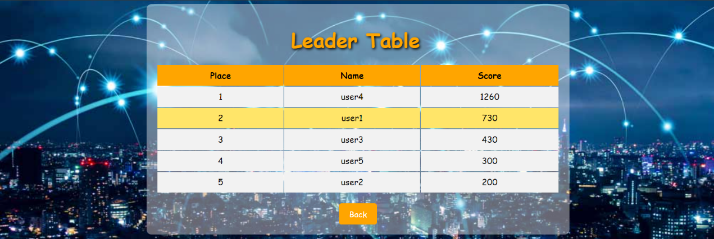

**Cinema screen:**

* Click on Watch button to see the video you want.
* Each video contains a title that related to the video.
* Click on Help button to get more information.



**Help pop-up in Home screen:**

* You can see more information about the game.

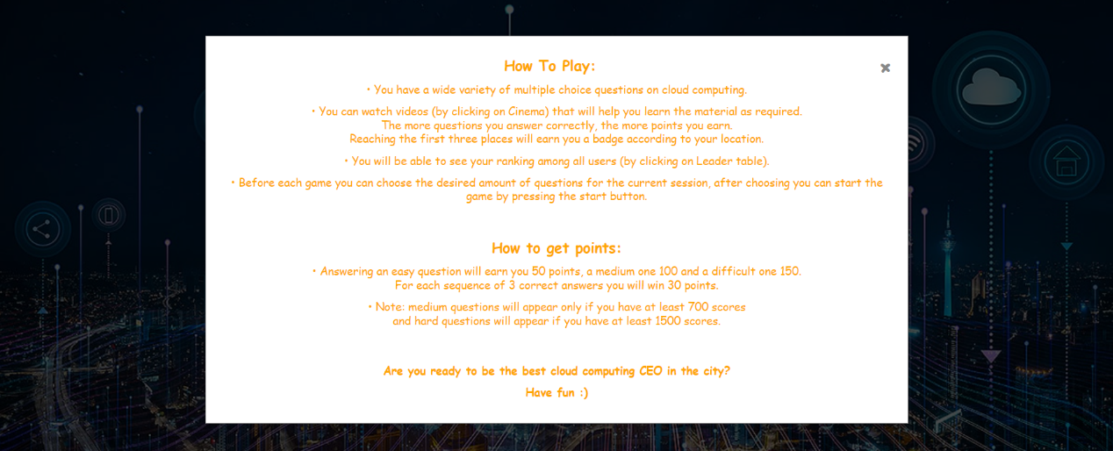

**Game screen:**

* You can see the number of questions you have in that session and the number of questions that you answered.
* You can see the question level.
* You can see the question and the four answers.
* To choose an answer click on that answer.

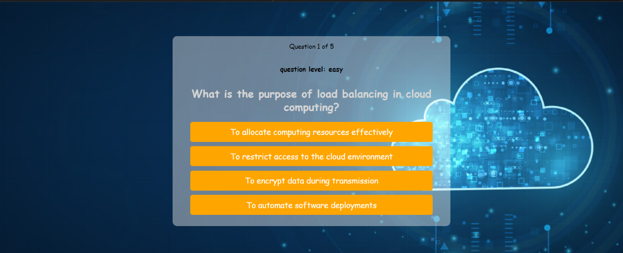

**Pop-up indicator in Game screen:**

* You can see if you right or wrong according to the display message.
* Click on Next Question to move on to the next question in the session.
* Click on the End Game button if you want to end your session in the middle.
* Note: in the screen below the shown pop-up is for correct answer.

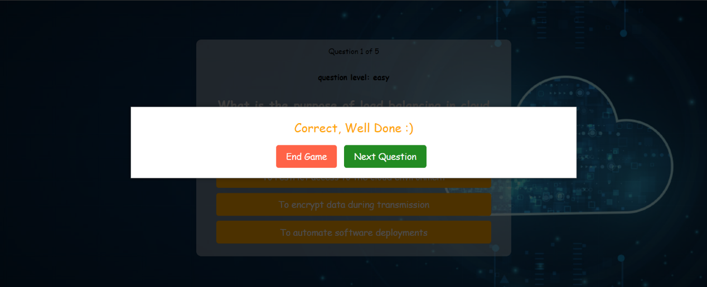

**Result screen:**

* Here you can see a summery for your session.
* You can see the number of questions that you answered correct.
* You can see how much score you got on that session.
* You can see how much questions you answered correct on a row.
* You can see how much time you play on that session.
* In the pie chart you can see in percentages the number of questions you answered correctly compared to the ones you got wrong.
* In the bar chart you can see how much score you got in your previous sessions (up to 3). The horizontal axis contains the session number, and the vertical axis contains the points for that session.
* Click on Back to Home Back to return to Home screen.

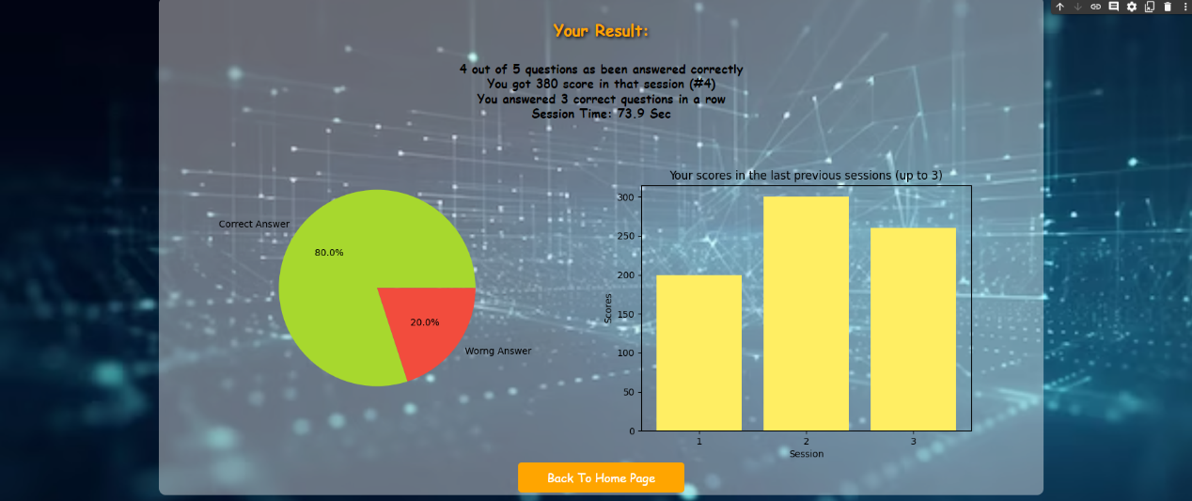

**Admin screen:**

* Click on Add question button to add a new question.
* Click on Edit question button to edit/delete question.
* Click on Add question button to add new video to the Cinema.
* Click on Logout to logout from the system.

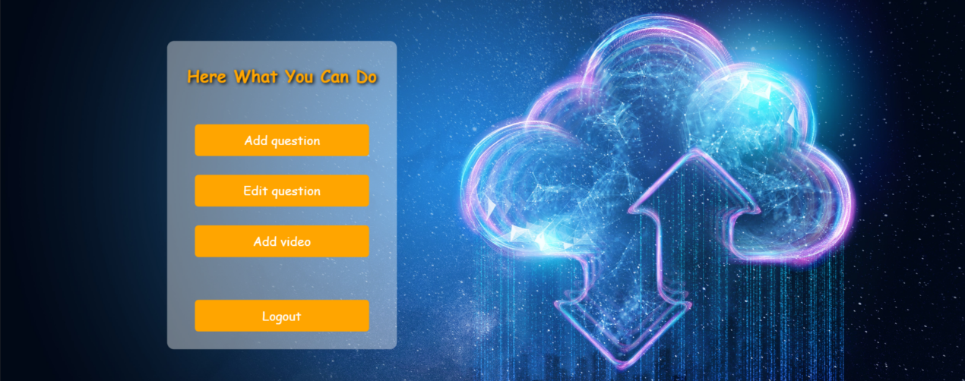

**Add Question screen:**

* Enter the question contact, option 1, option 2, option 3 and option 4.
* Choose from the correct dropdown the number of the correct option.
* Choose from the level dropdown the level of the question.
* Click on Add question to add that new question's data.
* Click on Back to return to Admin screen.
* Note: by not entering all the fields, the user gets an error message.

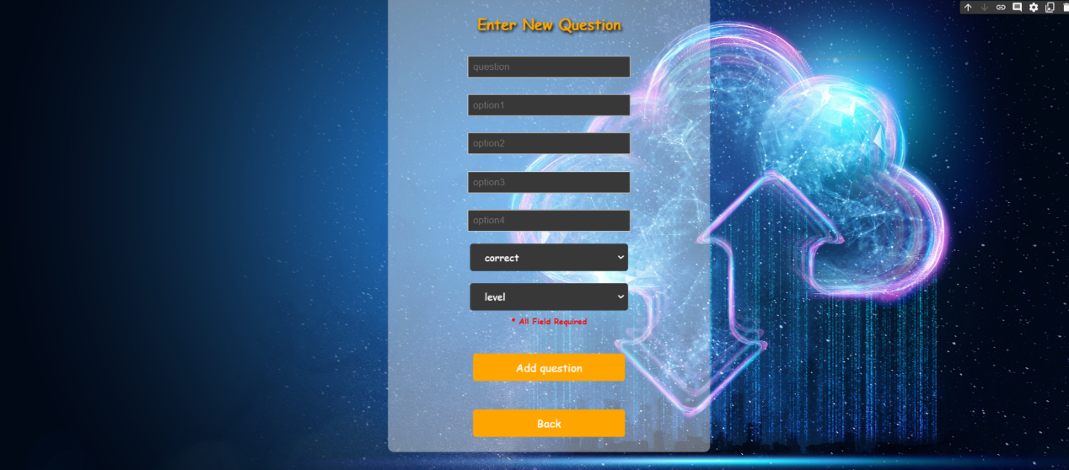

**Edit/Delete screen:**

* Choose a question form the dropdown.
* Click on Search to edit/delete the chosen question.
* Click on Back button to return to Admin screen.

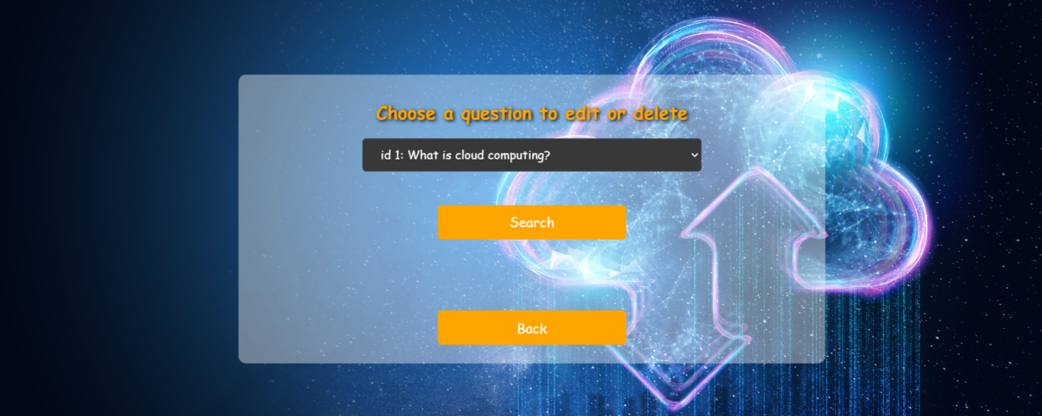

**Dropdown in the Edit/Delete screen:**

* You can see every question and her id.

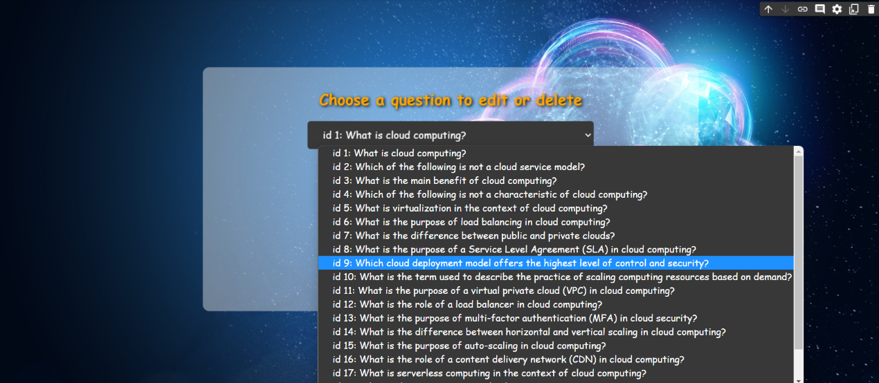

**Edit/Delete screen (after clicking on Search button):**

* If you want to edit the question data, enter the question contact, option 1, option 2, option 3 and option 4.
* Choose from the correct dropdown the number of the correct option.
* Choose from the level dropdown the level of the question.
* Click the Done button.
* If you want to delete that question, click on Delete button.
* Click on Back button to return to Edit/Delete screen (the screen above)
* Note: by not entering all the fields, the user gets an error message.

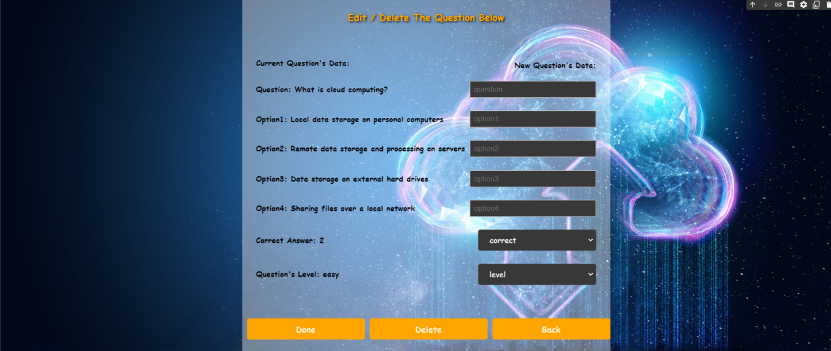

**Add Video screen:**

* Enter the image video, the title of the video and the video URL.
* Click on Add video button to add that.
* Click on Back button to return to Admin screen.
* Note: by not entering all the fields, the user gets an error message.

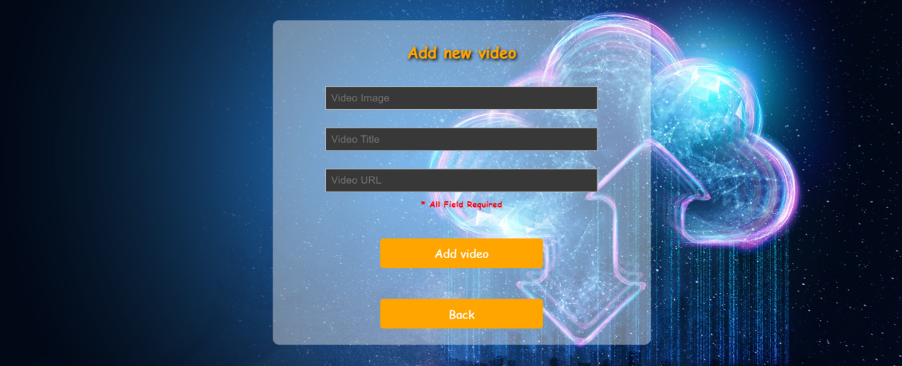

**Success pop-up:**

* After each successful action that admin does (add question, edit/delete question and add new video) he receives an appropriate message.
* Note: in the screen below the pop up that shown is after adding new video.

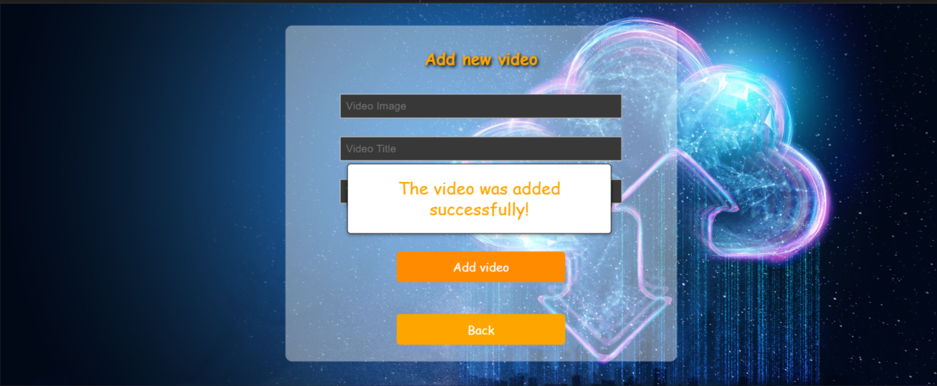

**קישור לתיקיית הgit:** https://github.com/ShiranGiladi/Cloud-Computing/tree/HW3  
**קישור למסד הנתונים:** https://hw02-2584c-default-rtdb.firebaseio.com/

**אתגרים בהם ניתקלנו –**

1. לא ניתן להפריד בין הקבצי HTML לפונקציונליות עצמה, אם מייבאים את דפי ה-HTML לא ניתן להוסיף להם tag-ים נוספים במהלך הריצה.
2. 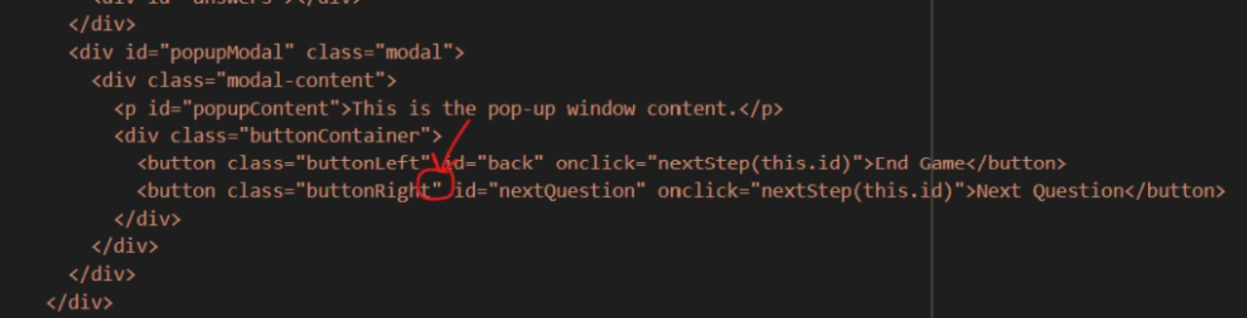לא ניתן לראות שגיאות במשתנים של HTML/JavaScript.  
   לדוגמא: באחד הכפתורים בתגית היה חסר סגירת מרכאות ב-class של כפתור מסוים, ולכן דברים לא עבדו לנו.